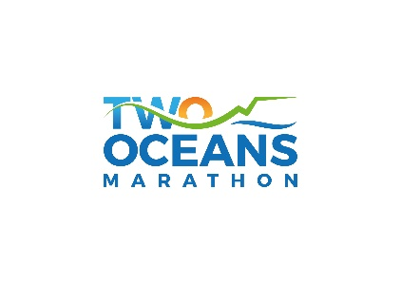
TOM 2021 Virtual Charity Challenge – Who to contact
Have a general question about the TOM 2021 Virtual Charity Challenge?
Email: info@twooceansmarathon.org.za
TOM Reception: 021 2000 459 Weekdays 8.30am to 5pm
TOM Race Office: 087 133 2285 Weekdays 8.30am to 5pm
Payment queries: support@easyreg.co.za (Payment queries)
BackaBuddy support
Need to contact the BackaBuddy team for help or info? Send them an email or Whatsapp now!
Email: lakiwe@backabuddy.co.za
Whatsapp: 079 194 9946
GivenGain support
Have a question about fundraising or want to have your favourite charity registered on GivenGain for TOM 2021? Contact GivenGain at fundraising@givengain.com.

